DISCOVERY FILE: Abiotic and Biotic Factors

Many factors influence every part of our environment: things like how tall trees grow, where animals and plants are found, and why birds migrate. There are two categories of these factors: abiotic and biotic.

Abiotic factors are the non-living parts of the environment that can often have a major influence on living organisms. Abiotic factors include water, sunlight, oxygen, soil and temperature.


Water (H₂O) is a very important abiotic factor – it is often said that “water is life.” All living organisms need water. Plants must have water to grow. Even plants that live in the desert need a little bit of water to grow. Without water, animals become weak and confused, and they can die if they do not rehydrate. Think of how you feel after you take a long run. Do you feel thirsty? This is your body signaling to you that you must rehydrate.
By Jon Sullivan [Public domain], via Wikimedia Commons


Sunlight is the main source of energy on Earth, which makes it an extremely important abiotic factor. Sunlight is necessary for photosynthesis, the process by which plants convert carbon dioxide (CO₂) and water to oxygen (O₂) and sugar – food for the plants that later becomes food for animals. Without the sun, plants could not live, and without plants, animals could not live! The sun’s heat is also extremely important – see the section on Temperature below.

Like water, oxygen (O₂) is another important abiotic factor for many living organisms. Without oxygen, humans would not be able to live! This is true for the many other living organisms that use oxygen. Oxygen is produced by green plants through the process of photosynthesis, and is therefore directly linked to sunlight.

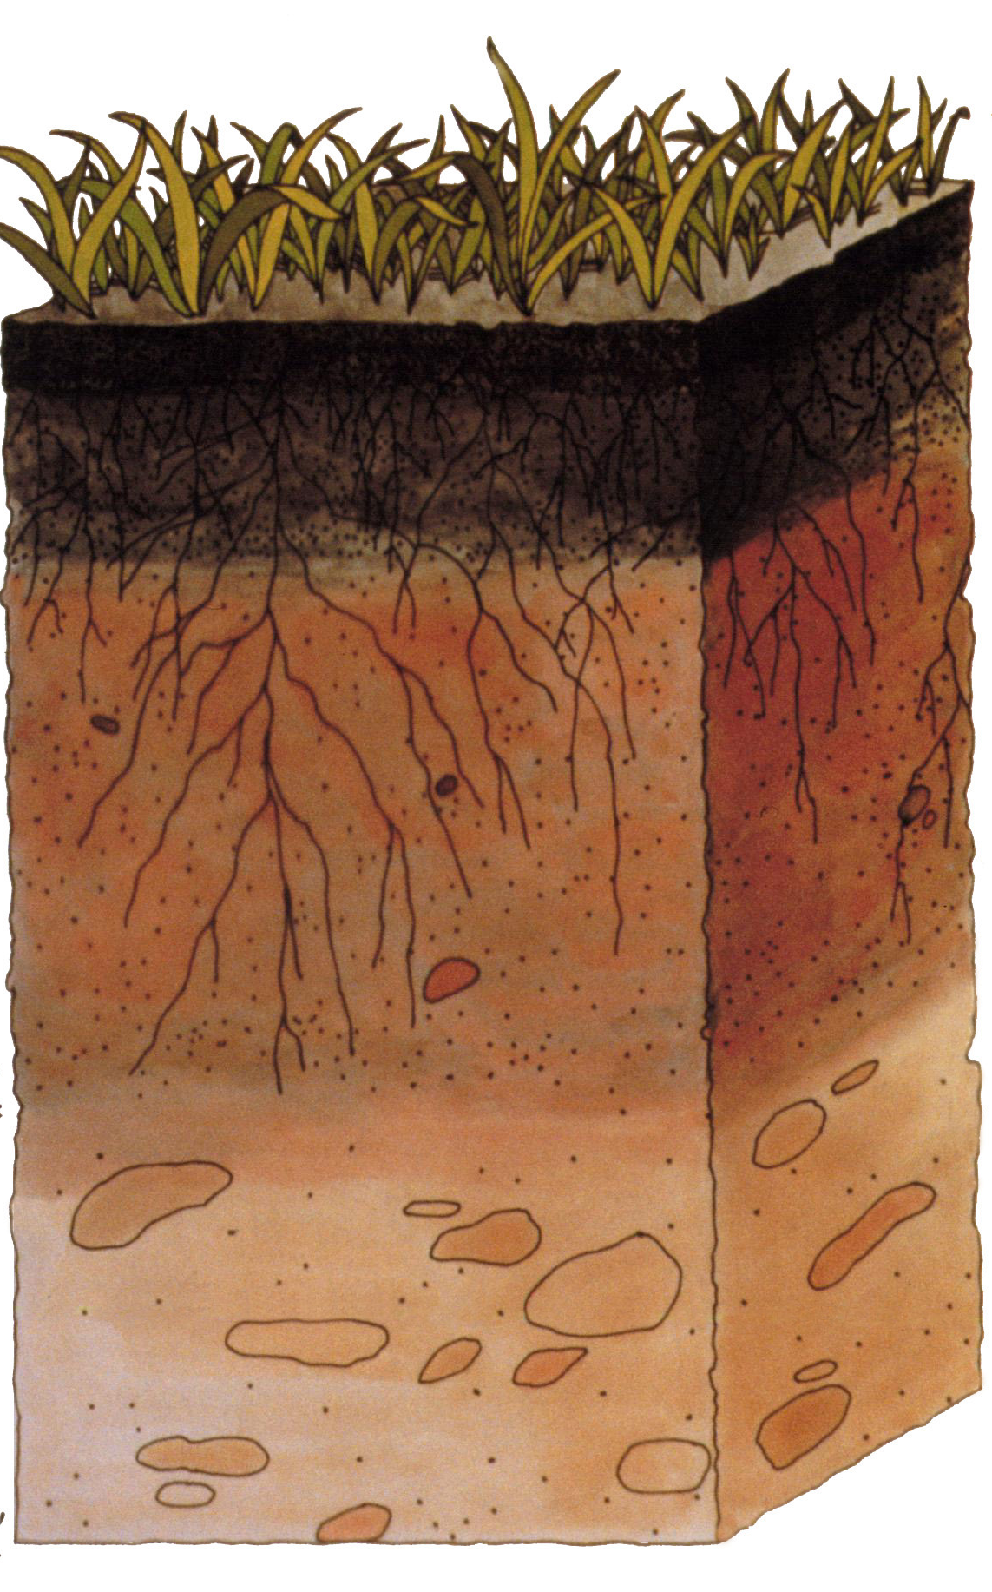
Soil is often considered an abiotic factor since it is mostly made up of small particles of rock (sand and clay) mixed with decomposed plants and animals. Plants use their roots to get water and nutrients from the soil. Soils are different from place to place – this can be a big factor in which plants and animals live in a certain area.

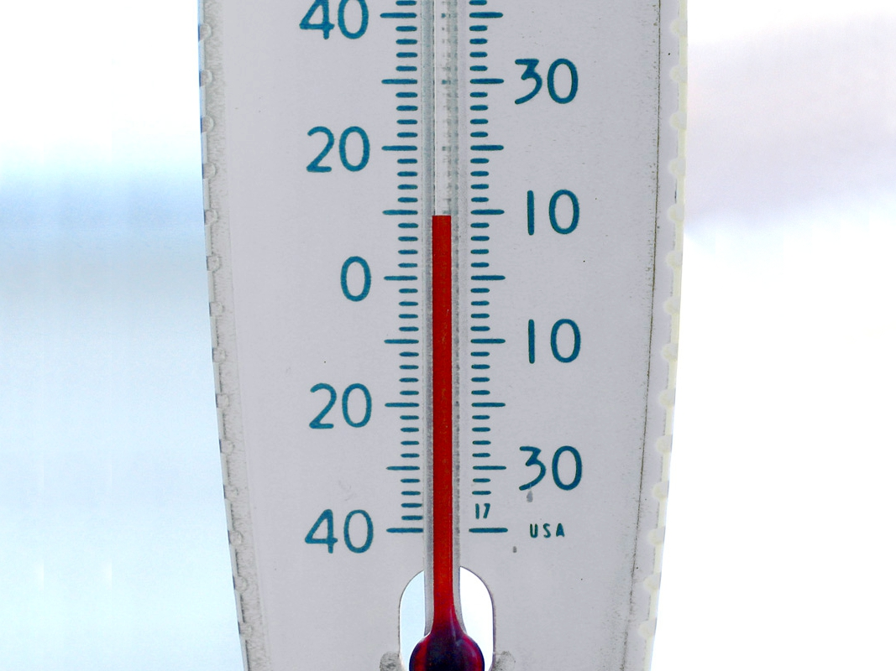
Credit: USDA [Public domain], via Wikimedia Commons

Temperature is an abiotic factor that is strongly influenced by sunlight. Temperature plays an important role for animals that cannot regulate their own body temperature, such as reptiles. Unlike humans, whose normal body temperature is usually around 98.6°F, reptiles (such as snakes and lizards) cannot maintain a constant body temperature. Reptiles are usually found in warm regions around the planet. To regulate their body temperatures, reptiles will sun themselves on rocks, which absorb heat from sunlight and then radiate heat back into the environment.
Credit: Don from USA (Flickr) [CC-BY-2.0],
via Wikimedia Commons

Biotic factors are all of the living things in an ecosystem, such as plants and animals. These living things interact with one another in many ways. Biotic factors and their interactions can be broken down into three groups:

1. Producers. All plants, such as grass and trees, are producers. These organisms absorb the sun’s energy and convert the energy into food for themselves, allowing them to grow larger, make flowers and seeds, etc.
2. Consumers. These organisms, mostly animals, eat producers and/or other animals. They may also eat decomposers. Two examples of consumers are deer (eat plants) and wolves (eat animals). Consumers that only eat plants (herbivores) are often known as primary consumers.
3. Decomposers. These organisms break down dead material (such as a fallen tree) into soil and return nutrients to the soil so they can be re-used by producers to create food. An example of a decomposer is a mushroom.

